LAB ACTIVITY (Exp-04)

1. Given a string s containing three types of brackets {}, () and []. Determine whether the Expression are balanced not. An expression is balanced if each opening bracket has a corresponding closing bracket of the same type, the pairs are properly ordered and no bracket closes before its matching opening bracket.

#include <stdio.h>
#include <stdlib.h>
#include <stdbool.h>
#include <string.h>

#define MAX 100

char stack[MAX];
int top = -1;

void push(char c) {
if (top == MAX - 1) {
printf("Stack overflow\n");
exit(1);
}
stack[++top] = c;
}

char pop() {
if (top == -1) {
printf("Stack underflow\n");
exit(1);
}
return stack[top--];
}

bool isEmpty() {
return top == -1;
}

bool isBalanced(char *exp) {
for (int i = 0; exp[i] != '\0'; i++) {
char ch = exp[i];

if (ch == '(' || ch == '{' || ch == '[') {
push(ch);
}
else if (ch == ')' || ch == '}' || ch == ']') {
if (isEmpty()) return false;

char topChar = pop();

if ((ch == ')' && topChar != '(') ||
(ch == '}' && topChar != '{') ||
(ch == ']' && topChar != '[')) {
return false;
}
}
}

return isEmpty();
}

int main() {
char exp[MAX];

printf("Enter an expression: ");
scanf("%s", exp);

if (isBalanced(exp)) {
printf("Balanced\n");
} else {
printf("Not Balanced\n");
}

return 0;
}

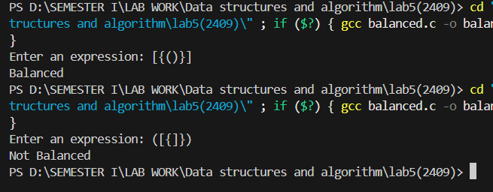

2. Given a stack with push(), pop(), and empty() operations, The task is to delete the middle element of it without using any additional data structure.

#include <stdio.h>
#include <stdlib.h>

#define MAX 100

int stack[MAX];
int top = -1;

void push(int x) {
if (top == MAX - 1) {
printf("Stack Overflow\n");
return;
}
stack[++top] = x;
}

int pop() {
if (top == -1) {
printf("Stack Underflow\n");
return -1;
}
return stack[top--];
}

int isEmpty() {
return top == -1;
}

void deleteMiddleUntil(int current, int size) {
if (isEmpty() || current == size) {
return;
}

int x = pop();

if (current != size / 2) {
deleteMiddleUntil(current + 1, size);
push(x);
} else {
deleteMiddleUntil(current + 1, size);
}
}

void deleteMiddle() {
int size = top + 1;
deleteMiddleUntil(0, size);
}

void printStack() {
for (int i = top; i >= 0; i--) {
printf("%d ", stack[i]);
}
printf("\n");
}

int main() {
int n, val;

printf("Enter number of elements in stack: ");
scanf("%d", &n);

printf("Enter %d elements: ", n);
for (int i = 0; i < n; i++) {
scanf("%d", &val);
push(val);
}

printf("\nOriginal Stack (Top to Bottom): ");
printStack();

deleteMiddle();

printf("After Deleting Middle Element: ");
printStack();

return 0;
}

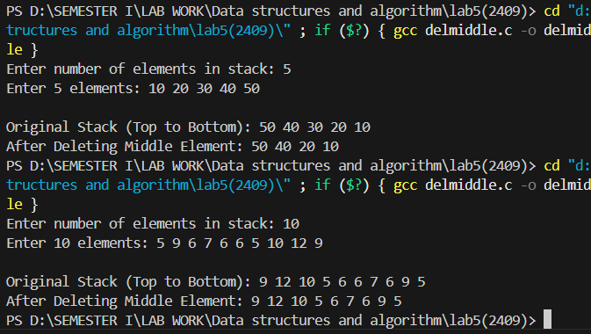

3. Implement Stack operations using Linked List.

#include <stdio.h>
#include <stdlib.h>

struct Node {
int data;
struct Node* next;
};

struct Node* top = NULL;

void push(int x) {
struct Node* newNode = (struct Node*)malloc(sizeof(struct Node));
newNode->data = x;
newNode->next = top;
top = newNode;
}

int pop() {
if (top == NULL) {
printf("Stack Underflow\n");
return -1;
}
struct Node* temp = top;
int popped = temp->data;
top = top->next;
free(temp);
return popped;
}

int peek() {
if (top == NULL) {
printf("Stack is empty\n");
return -1;
}
return top->data;
}

void display() {
struct Node* temp = top;
if (temp == NULL) {
printf("Stack is empty\n");
return;
}
printf("Stack (Top to Bottom): [");
while (temp != NULL) {
printf("%d ", temp->data);
temp = temp->next;
}
printf("]\n");
}

int main() {
int n, val;

printf("Enter number of elements in stack: ");
scanf("%d", &n);

printf("Enter %d elements:\n", n);
for (int i = 0; i < n; i++) {
scanf("%d", &val);
push(val);
}

printf("\nStack created successfully!\n");
display();

printf("Top element is %d\n", peek());

printf("Popped element is %d\n", pop());
display();

return 0;
}

